Institute of Engineering & Technology
Department of Computer Engineering & Application


PLANT DISEASE DETECTOR

A Project Report submitted in partial fulfilment of the requirements
for the award of the degree of

Bachelor of Technology

in

Computer Science and Engineering

by

Name of Students Roll No.
- Devesh Thakur (161500195)
- Rambandhu Sharma (161500438)
- Paritosh Pandey (161500374)
4. Rajeev Kumar (171599007)

Under the Guidance of

Mr.Shashi Shekhar,

Department of Computer Engineering & Applications

Institute of Engineering & Technology

GLA University

Mathura- 281406, INDIA

May, 2020


Department of Computer Engineering and Applications

GLA University, 17 km. Stone NH#2, Mathura-Delhi Road, Chaumuha, Mathura – 281406 U.P (India)

Declaration

I hereby declare that the work which is being presented in the B.Tech. Project “Plant Disease Detection”, in partial fulfillment of the requirements for the award of the Bachelor of Technology in Computer Science and Engineering and submitted to the Department of Computer Engineering and Applications of GLA University, Mathura, is an authentic record of my own work carried under the supervision of Mr. Shashi Shekhar(Asst. Prof).
The contents of this project report, in full or in parts, have not been submitted to any other Institute or University for the award of any degree.

Sign ______________________ Sign ______________________
Name of Candidate:Devesh Thakur Name of Candidate:Paritosh Pandey
University Roll No.: 161500195 University Roll No.:161500374

Sign ______________________ Sign ______________________
Name of Candidate:Rambandhu Sharma Name of Candidate:Rajeev Kumar
University Roll No.:161500438 University Roll No.:171599007

Certificate

This is to certify that the above statements made by the candidate are correct to the best of my/our knowledge and belief.

___________________

Supervisor
Mr. Shashi Shekhar
(Asst. Professor)

____________________ ___________________

Project Coordinator Program Coordinator

(Mr. Mayank Srivastava) (Mr. Himanshu Sharma)

Date:

ACKNOWLEDGEMENT

I would like to express my deep gratitude to our guide, Mr. Shashi Shekhar (Asst. Professor).

It was only with his backing and support that I could complete the project. He provided me all sorts of help and corrected me if ever seemed to make mistakes. He provided me with all the necessary resources and guidance during the project which helped me to complete the project successfully.

We sincerely thank to our Head of the Department, Dr. A.S.Jalal and Program Coordinator, Mr. Himanshu Sharma. We are also grateful to Dr. Anoop Kumar Gupta, Professor and Director,GLA University for giving us the necessary facilities to carry out our project work successfully.

Finally, I am also thankful to my colleagues and friends for their support. And at last but not the least, I would like to express our sincere gratitude to my parents who have shown us this world and for being supportive all the time.

Project Group Members: | University Roll No.: | Signature:
- DeveshThakur | (161500195)
- Paritosh Pandey | (161500374)
- Rajeev Kumar | (171599007)
- Rambandhu Sharma | (161500438)

ABSTRACT

When plants and crops are affected by pests it affects the agricultural production of the country. Usually farmers or experts observe the plants with the naked eye for detection and identification of disease. But this method can be time processing, expensive and inaccurate. Automatic detection using image processing techniques provide fast and accurate results. This paper is concerned with a new approach to the development of plant disease recognition model, based on leaf image classification, by the use of deep convolutional networks. Advances in computer vision present an opportunity to expand and enhance the practice of precise plant protection and extend the market of computer vision applications in the field of precision agriculture. Novel way of training and the methodology used to facilitate a quick and easy system implementation in practice. All essential steps starting from gathering images to create a database, assessed by agricultural experts, a deep learning framework to perform the deep CNN training. This is a new approach in detecting plant diseases using the deep convolutional neural network trained and fine-tuned to fit accurately to the database of a plant's leaves that was gathered independently for diverse plant diseases. The advance and novelty of the developed model lie in its simplicity; healthy leaves and background images are in line with other classes, enabling the model to distinguish between diseased leaves and healthy ones or from the environment by using KNN. This paper also compares the benefits and limitations of these potential methods. It includes several steps viz. image acquisition, image pre-processing, feature extraction and neural network-based classification.
Keywords: Disease detection, Image acquisition, pre-processing, features extraction, classification, symptoms, and neural network.

List of Figures

1.1 | Training and Testing Diagram Representation | 5
1.2 | Working of CNN | 5
2.1 | Training and Validation Accuracy Graph | 6
3.1 | Output Image | 7

List of Tables

1.1 | Requirement Analysis | 2

CONTENTS

Declaration ii
Certificate ii
Acknowledge iii
Abstract iv
List of figures v
List of Tables vi

CHAPTER 1 Introduction 1
1.1 Overview and Motivation 1
1.2 Objective 1
CHAPTER 2 Software Requirement Analysis 2
2.1 Requirement Analysis 2
2.2 Feasibility Study 2
2.3 Introduction 2
2.4 Material & Methods 3
2.5 Image Preprocessing and Labelling 3
2.6 Neural Network Training 3
2.7 CNN Algo Summary 4
CHAPTER 3 Software Design 5
3.1 Training and Testing Diagram Representation 5
3.2 Working of CNN 5
CHAPTER 4 Implementation and User Interface 6
  - Training and Validation Accuracy Graph 6
  - Output 7
CHAPTER 5 Conclusion 8
CHAPTER 6 Summary 9
Bibliography 9
Appendices: References 9

CHAPTER 1: INTRODUCTION

India is an agricultural country and ranks second worldwide in farm outputs. Agriculture employed more than 50℅ of the Indian workforce and contributed 17–18% to the country's GDP. Research in this sector is aimed to increase the productivity, food quality and quantity at reduced expenditures. When plants and crops in the field are suffering from pests it affects the agricultural production of the country. Studies show that the quality of products is reduced due to plant diseases. Diseases are impairment to the normal state of the plant that interrupts its vital functions such as photosynthesis, pollination, fertilization, etc. Pathogens (like fungi, bacteria and viruses), and adverse environmental conditions are a major cause of diseases. Therefore, the first stage diagnosis of disease is a crucial task. Usually farmers observe the plants with the naked eye for detection and identification of disease which calls for a tough decision on selecting the right fertilizer to use and this method can be time-consuming, expensive, and inaccurate. Automatic detection using image processing techniques provide fast and accurate results. This paper comes with a reviewed approach for plant disease recognition by leaf image classification. There are several ways to detect plant pathology but some diseases don't have any visible symptoms, or the effect becomes noticeable too late to act, and in those situations, a sophisticated analysis is mandatory. This technique will improve the productivity of crops. The objective of this paper is to concentrate on plant diseases because timely and accurate diagnosis of plant diseases is one of the pillars of precision agriculture. It is crucial to prevent unnecessary waste of financial and other resources, thus achieving healthier production.
We can use Machine Learning libraries like Tensorflow, Keras, OpenCV, which provides many inbuilt functions for image processing to detect plant disease. This paper is organized into the following sections.

1.1 Overview and Motivation

The main motive of this project to get the knowledge of the plant diseases because some of the people are unaware of plants their type thy get affected by touching them. We can use python libraries like tensorflow, keras, Opencv, which provides many in-build function for image processing to detect plant disease using machine learning. It should be count as a major project because it has variety of scope in wide range of areas specially in agricultural fields.

1.2 Objective
Our main objective it to find a method to detect disease in plants not by conventional method but with the help of machines and technology .As farmers are not able to detect which plant has which disease and they are not fully aware of all the medicines for these.As the see with the naked eye only. Our model can predict the disease and the type of plant with 97% accuracy and can also suggest the the proper medicine to be used to cure the disease of plant. All this is possible with the use of new technology of machine learning.

CHAPTER 2: SOFTWARE REQUIREMENT ANALYSIS.
Requirement Analysis:
Hardware Requirements:  - 8GB RAM  - 4GB Graphic Card  - Intel Core i5 | Software Requirements:  - Python IDE  - External Libraries of Python TensorFlow - 1.11.0,  Keras - 2.2.4,  OpenCV - 3.4.1.15,  Numpy - 1.14.3,  Scikit-learn - 0.19.1)

Feasibility study: To discuss the feasibility of the system to be developed

Leaf image is captured and processed to determine the health status of each plant. Currently the chemicals are applied to the plants periodically without considering the requirement of each plant. This technique will ensure that the chemicals only applied when the plants are detected to be effected with the diseases. The plant disease detection through leaf image is very useful and inexpensive system specially for assisting farmers in monitoring the big plantation area so it will be helpful in future.
INTRODUCTION
India is an agricultural country and ranks second worldwide in farm outputs. Agriculture employed more than 50℅ of the Indian workforce and contributed 17–18% to the country's GDP. Research in this sector is aimed to increase the productivity, food quality and quantity at reduced expenditures. When plants and crops in the field are suffering from pests it affects the agricultural production of the country. Studies show that the quality of products is reduced due to plant diseases. Diseases are impairment to the normal state of the plant that interrupts its vital functions such as photosynthesis, pollination, fertilization, etc. Pathogens (like fungi, bacteria and viruses), and adverse environmental conditions are a major cause of diseases. Therefore, the first stage diagnosis of disease is a crucial task. Usually farmers observe the plants with the naked eye for detection and identification of disease which calls for a tough decision on selecting the right fertilizer to use and this method can be time-consuming, expensive, and inaccurate. Automatic detection using image processing techniques provide fast and accurate results. This paper comes with a reviewed approach for plant disease recognition by leaf image classification. There are several ways to detect plant pathology but some diseases don't have any visible symptoms, or the effect becomes noticeable too late to act, and in those situations, a sophisticated analysis is mandatory. This technique will improve the productivity of crops. The objective of this paper is to concentrate on plant diseases because timely and accurate diagnosis of plant diseases is one of the pillars of precision agriculture. It is crucial to prevent unnecessary waste of financial and other resources, thus achieving healthier production.
We can use Machine Learning libraries like Tensorflow, Keras, OpenCV, which provides many inbuilt functions for image processing to detect plant disease.

Materials and Methods: -

The Data-set was taken from Kaggle of Plant Village Data-set present online as such the code was also written on the online kernel of Kaggle for better computation and analysis of training loss and validation.

Image Preprocessing and Labelling:

Preprocessing images commonly involves removing low-frequency background noise, normalizing the intensity of the individual particles images, removing reflections, and masking portions of images. Image preprocessing is the technique of enhancing data Furthermore, procedure of image preprocessing involved cropping of all the images manually, making the square around the leaves, in order to highlight the region of interest (plant leaves). During the phase of collecting the images for the Data-set, images with smaller resolution and dimension less than 500 pixels were not considered as valid images for the Data-set. In addition, only the images where the region of interest was in higher resolution were marked as eligible candidates for the Data-set. In that way, it was ensured that images contain all the needed information for feature learning. Many resources can be found by searching across the Internet, but their relevance is often unreliable. In the interest of confirming the accuracy of classes in the Data-set, initially grouped by a keywords search, agricultural experts examined leaf images and labeled all the images with appropriate disease acronym. As it is known, it is important to use accurately classified images for the training and validation Data-set. Only in that way may an appropriate and reliable detecting model be developed. In this stage, duplicated images that were left after the initial iteration of gathering and grouping images into classes were removed from the Data-set.

Neural Network Training:
A supervised machine learning algorithm (as opposed to an unsupervised machine learning algorithm) is one that relies on labeled input data to learn a function that produces an appropriate output when given new unlabeled data.
Imagine a computer is a child, we are its supervisor (e.g. parent, guardian, or teacher), and we want the child (computer) to learn what a pig looks like. We will show the child several different pictures, some of which are pigs and the rest could be pictures of anything (cats, dogs, etc)
Supervised machine learning algorithms are used to solve classification or regression problems.
A classification problem has a discrete value as its output. For example, “likes pineapple on pizza” and “does not like pineapple on pizza” are discrete. There is no middle ground. The analogy above of teaching a child to identify a pig is another example of a classification problem.
This image shows a basic example of what classification data might look like. We have a predictor (or set of predictors) and a label. In the image, we might be trying to predict whether someone likes pineapple (1) on their pizza or not (0) based on their age (the predictor).
It is standard practice to represent the output (label) of a classification algorithm as an integer number such as 1, -1, or 0. In this instance, these numbers are purely representational. Mathematical operations should not be performed on them because doing so would be meaningless. Think for a moment. What is “likes pineapple” + “does not like pineapple”? Exactly. We cannot add them, so we should not add their numeric representations.
A regression problem has a real number (a number with a decimal point) as its output. For example, we could use the data in the table below to estimate someone’s weight given their height.
Data used in a regression analysis will look similar to the data shown in the image above. We have an independent variable (or set of independent variables) and a dependent variable (the thing we are trying to guess given our independent variables). For instance, we could say height is the independent variable and weight is the dependent variable.
Also, each row is typically called an example, observation, or data point, while each column (not including the label/dependent variable) is often called a predictor, dimension, independent variable, or feature.
CNN Algorithm Summary
- Provide input image into convolution layer
- Choose parameters, apply filters with strides, padding if requires.
- Perform convolution on the image and apply ReLU activation to the
matrix.
- Perform pooling to reduce dimensionality size
- Add as many convolutional layers until satisfied
- Flatten the output and feed into a fully connected layer (FC Layer)
- Output the class using an activation function (Logistic Regression with cost functions) and classifies images.

CHAPTER 3: SOFTWARE DESIGN

Training and Testing Diagram Representation:

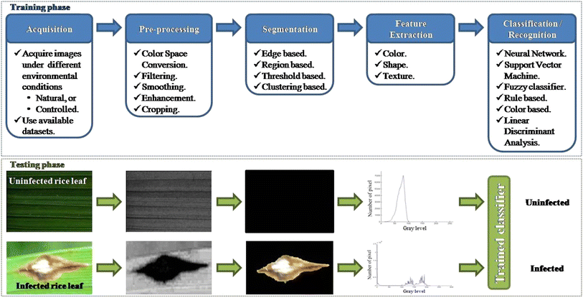

Working of CNN:
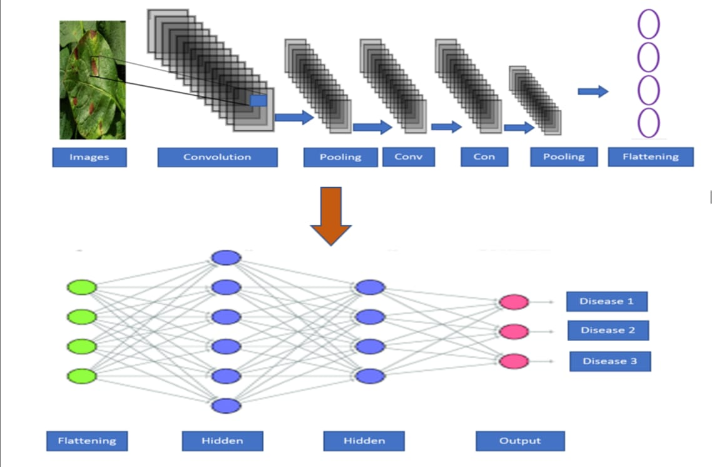

CHAPTER 4: IMPLIMENTATION AND USER INTERFACE

Training and Validation Accuracy Graph :

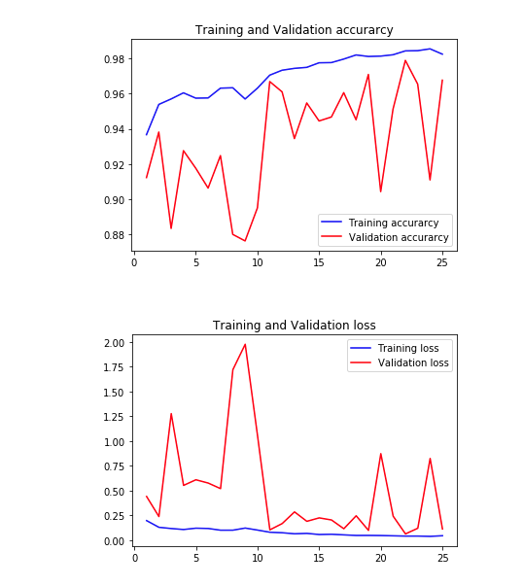

Output :
Testing Accuracy = 95.96%

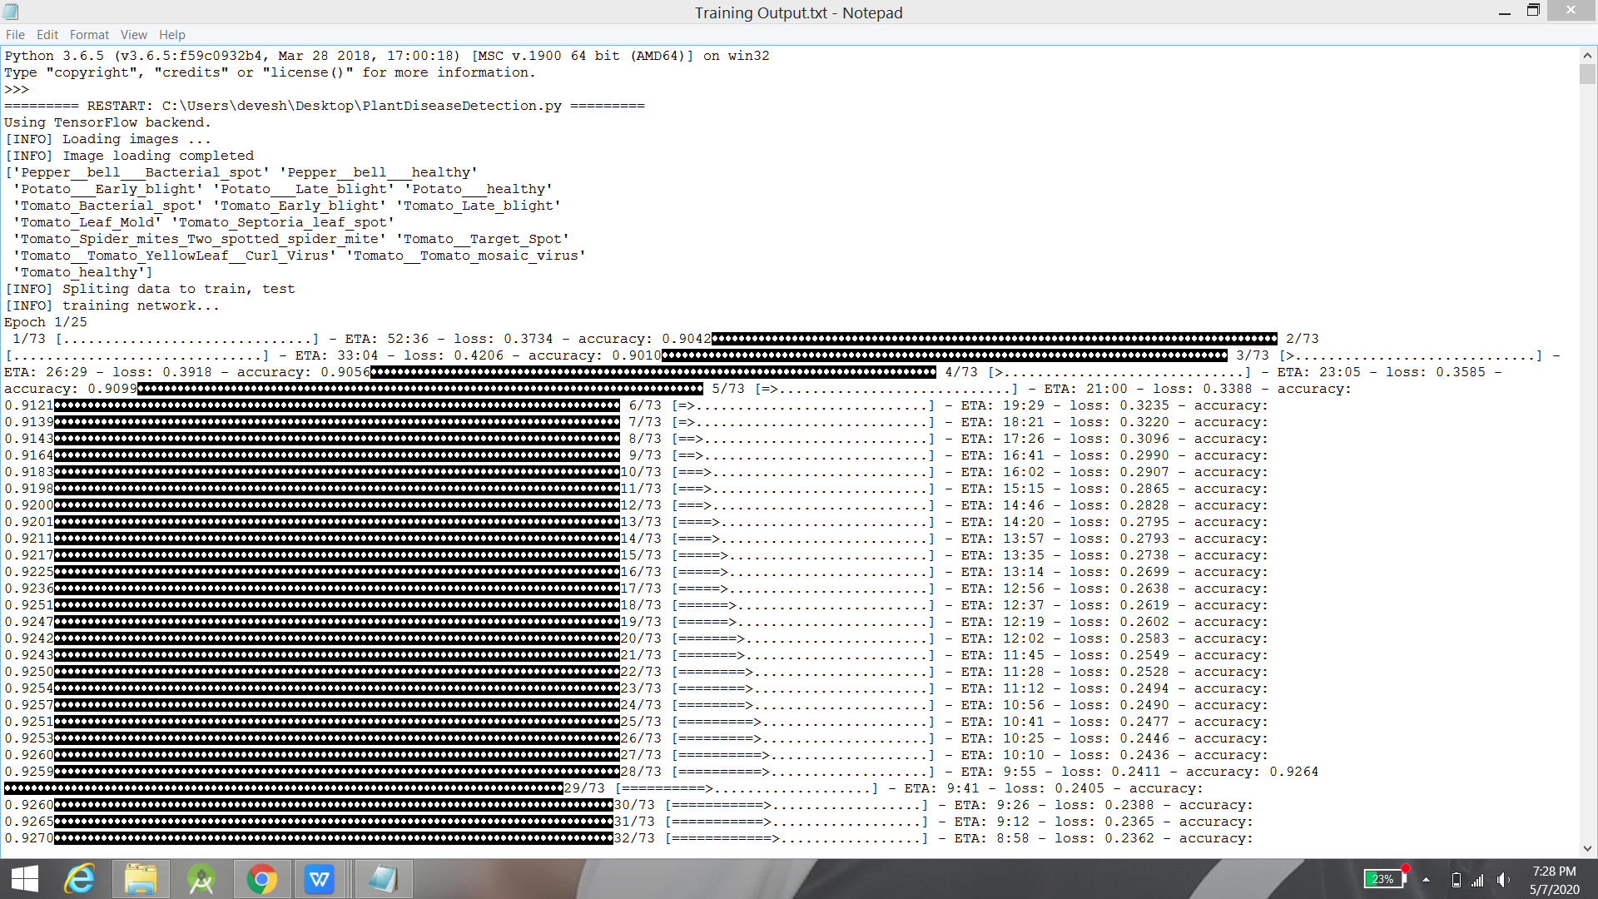
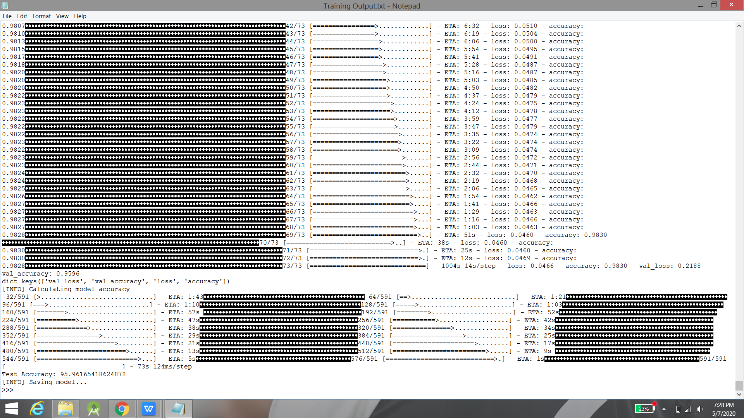

Chapter 5: CONCLUSION

In this project, an approach of using deep learning method was explored in order to automatically classify and detect plant diseases from leaf image. The major techniques for detection of plant diseases are: BPNN, SVM, K-means clustering, and SGDM. These techniques are used to analyse the healthy and diseased plants leaves. Some of the challenges in these techniques viz. effect of background data in the resulting image, optimization of the technique for a specific plant leaf diseases, and automation of the technique for continuous automated monitoring of plant leaf diseases under real world field conditions. The review suggests that this disease detection technique shows a good potential with an ability to detect plant leaf diseases and some limitations.The complete procedure was described, respectively, from collecting the images used for training and validation to image pre-processing and augmentation and finally the procedure of training the deep CNN and fine-tuning. Different tests will be performed in order to check the performance of newly created model. As the presented method has not been exploited. Therefore, there is scope of improvement in the existing research.

CHAPTER 6: SUMMARY

Bibliography

Appendices: REFERENCES

[1] Anand H. Kulkarni, Ashwin Patil R. K., Applying image processing technique to detect plant diseases, International Journal of
Modern Engineering Research, vol.2, Issue.5, pp: 3661-3664, 2012.
[2] F. Argenti,L. Alparone,G. Benelli ,” Fast algorithms for texture analysis using co-occurrence matrices” Radar and Signal Processing,
IEE Proceedings , vol. 137, Issue 6, pp:443-448 , No. 6, December 1990.
[3] P. Revathi, M. Hemalatha, Classification of Cotton Leaf Spot Diseases Using Image Processing Edge Detection Techniques, IEEE
International Conference on Emerging Trends in Science, Engineering and Technology, pp-169-173, Tiruchirappalli, Tamilnadu,
India, 2012.
[4] Tushar H. Jaware, Ravindra D. Badgujar and Prashant G. Patil, Crop disease detection using image segmentation, National
Conference on Advances in Communication and Computing, World Journal of Science and Technology, pp:190-194, Dhule,
Maharashtra, India, 2012.
[5] Prof.Sanjay B. Dhaygude, Mr.Nitin P. Kumbhar, Agricultural plant Leaf Disease Detection Using Image Processing, International
Journal of Advanced Research in Electrical, Electronics and Instrumentation Engineering , S & S Publication vol. 2, Issue 1, pp:
599-602, 2013.
[6] Mokhled S. Al-Tarawneh An Empirical Investigation of Olive Leave Spot Disease Using Auto-Cropping Segmentation and Fuzzy
C-Means Classification, World Applied Sciences Journal , vol.23, no.9, pp:1207-1211,2013.
[7] Yan-Cheng Zhang, Han-Ping Mao, Bo Hu, Ming -Xi Li, Feature Selection of Cotton Disease leaves Image Based on Fuzzy feature
Selection Techniques, Proceedings of the 2007 International Conference on Wavelet Analysis and Pattern Recognition, pp:124-129,
Beijing, China, Nov. 2007.
[8] Haiguang Wang, Guanlin Li, Zhanhong Ma, Xiaolong Li, Image Recognition of Plant Diseases Based on Back propagation
Networks, 5th International Congress on Image and Signal Processing, pp-894-900, Chongqing, China, 2012
[9] Simona E. Grigorescu, Nicolai Petkov, and Peter Kruizinga, Comparison of Texture Features Based on Gabor Filters , IEEE
ransaction on Image Processing, vol. 11, No. 10, pp-1160-1167, oct 2002 .
[10] S. Arivazhagan , R. Newlin Shebiah , S. Ananthi, S. Vishnu Varthini , Detection of unhealthy region of plant leaves and
classification of plant leaf diseases using texture features, Commission Internationale du Genie Rural(CIGR) journal, vol. 15, no.1,
pp:211-217, March 2013.
[11] Dheeb Al Bashish, M. Braik, and S. Bani-Ahmad, A Framework for Detection and Classification of Plant Leaf and Stem Diseases,
2010 International Conference on Signal and Image Processing, pp: 113-118, Chennai, India, 2010.
[12] Song Kai, liu zhikun, Su hang, Guo chunhong , A Research of maize disease image recognition of Corn Based on BP Networks,
Third International Conference on Measuring Technology and Mechatronics Automation,pp:246-249, Shenyang , China, 2011.
[13] H. Al-Hiary, S. Bani-Ahmad, M. Reyalat, M. Braik and Z. ALRahamneh, Fast and Accurate Detection and Classification of Plant
Diseases, International Journal of Computer Applications, Wageningen Academic publishers, vol. 17, no.1, pp: 31-38, March 2011.
[14] A.Menukaewjinda, P.Kumsawat, K.Attakitmongcol, A.Srikaew, Grape leaf disease detection from color imagery using hybrid
intelligent system, Proceedings of electrical Engineering/electronics, Computer, Telecommunications and Information technology
(ECTI-CON), vol 1. pp: 513-516, Krabi, Thailand, 2008.

